DAY 15 – AI EVOLUTION & HUGGING FACE MODEL EXPLORATION
Date: 21/09/2026

1. Task
Learn the evolution of Artificial Intelligence from traditional AI and Machine Learning to Deep Learning, Natural Language Processing, Generative AI, and Large Language Models. Create and explore a Hugging Face account and Model Hub. Test at least three different AI models for Text Generation, Sentiment Analysis, and Summarization. Compare their outputs and document the observations.

2. Evolution of Artificial Intelligence
Stage | Description
Traditional AI | Rule-based systems that follow predefined rules to solve specific problems.
Machine Learning | Systems learn patterns from data and use them to make predictions or decisions.
Deep Learning | Neural networks with multiple layers learn complex patterns from large datasets.
Natural Language Processing (NLP) | AI techniques that allow computers to process and understand human language.
Generative AI | Models that generate new content such as text, images, audio, and code.
Large Language Models (LLMs) | Large neural language models trained on huge text datasets to understand and generate natural language.

3. Hugging Face Model Hub
Hugging Face Model Hub is an online platform where developers and researchers can discover, share, and test machine learning models. During this task, the Model Hub was explored through the browser, avoiding local Python package and dependency issues.
The following three models were tested:
- GPT-2 – Text Generation
- DistilBERT fine-tuned on SST-2 – Sentiment Analysis
- BART Large CNN – Summarization

4. Model 1 – GPT-2 (Text Generation)
Model: openai-community/gpt2
Task: Text Generation
Input used: “Artificial Intelligence is changing the way”
Output observation: GPT-2 generated a continuation discussing how AI changes the way people interact and describing AI applications, innovation, and its future.
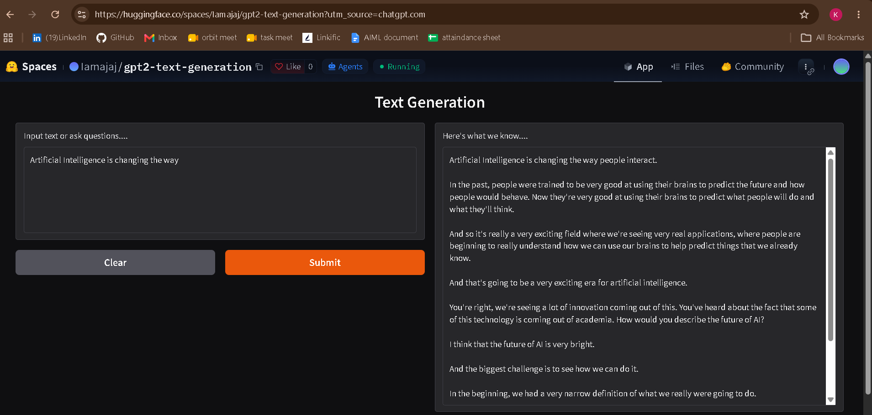
Figure 1: GPT-2 Text Generation test result

5. Model 2 – DistilBERT SST-2 (Sentiment Analysis)
Model: distilbert/distilbert-base-uncased-finetuned-sst-2-english
Task: Sentiment Analysis / Text Classification
Input used: “I really enjoyed learning about artificial intelligence today.”
Output: POSITIVE – 1.000; NEGATIVE – 0.000
Observation: The model classified the sentence as strongly positive. A score of 1.000 indicates that the model assigned its highest displayed confidence to the POSITIVE class.
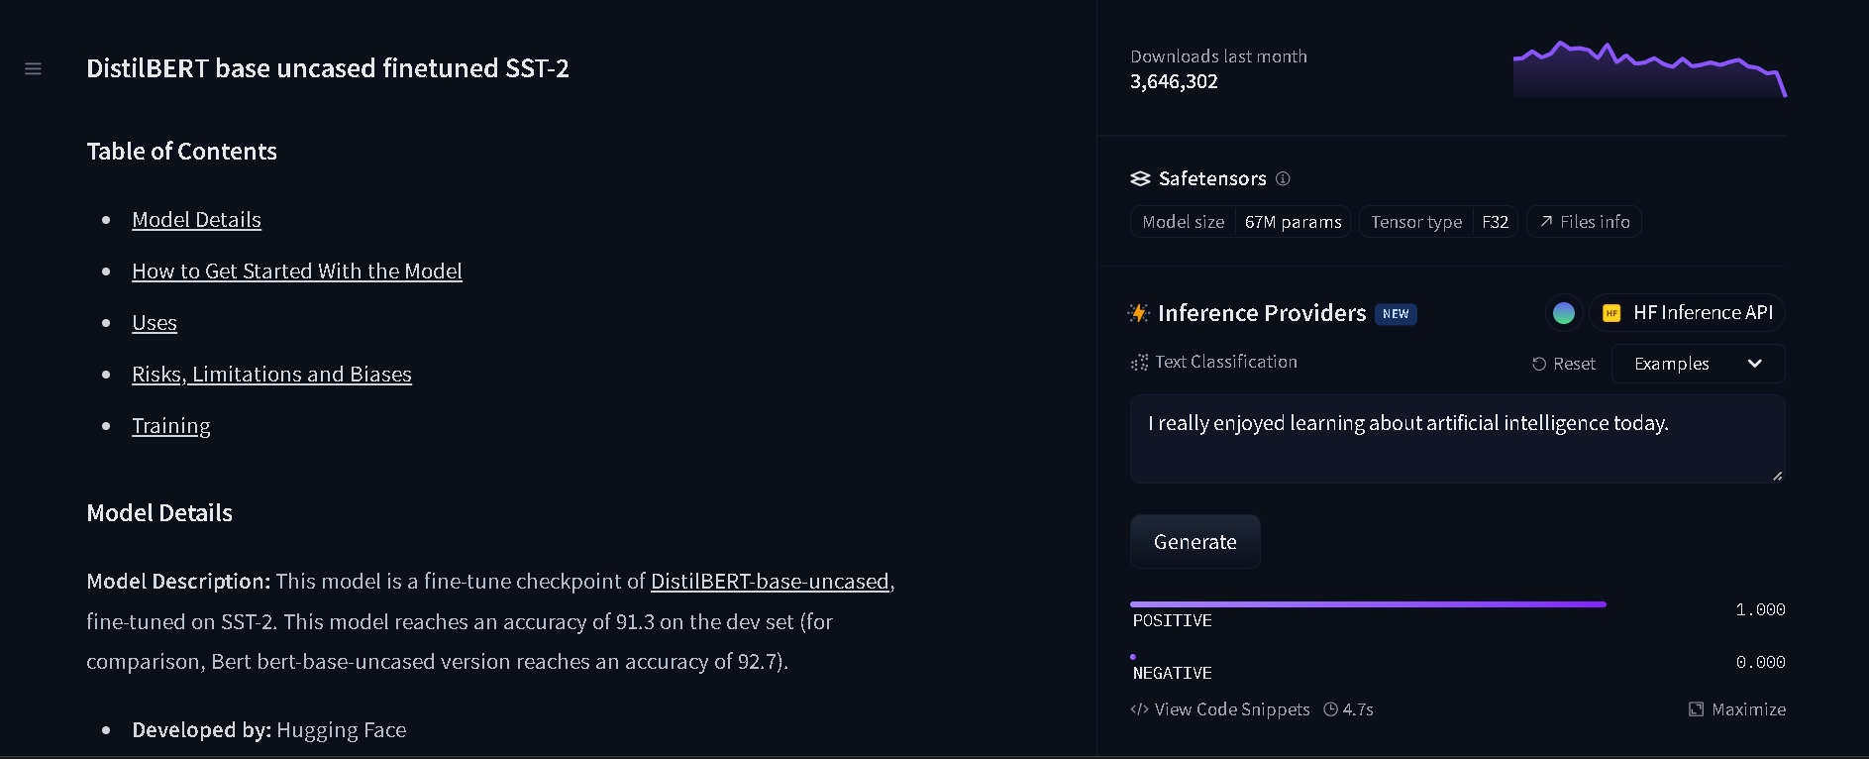
Figure 2: DistilBERT Sentiment Analysis test result

6. Model 3 – BART Large CNN (Summarization)
Model: facebook/bart-large-cnn
Task: Text Summarization
A longer paragraph about Artificial Intelligence, Machine Learning, Generative AI, healthcare, education, business, software development, risks, and responsible AI use was provided.
Output observation: BART reduced the longer input to a shorter passage focusing mainly on Artificial Intelligence, Machine Learning, and Generative AI. This second test demonstrated the summarization capability more clearly than the initial short input.
Note: The first short summarization test did not significantly shorten the text and also introduced an unrelated sentence. The longer second input produced a more useful condensed result.
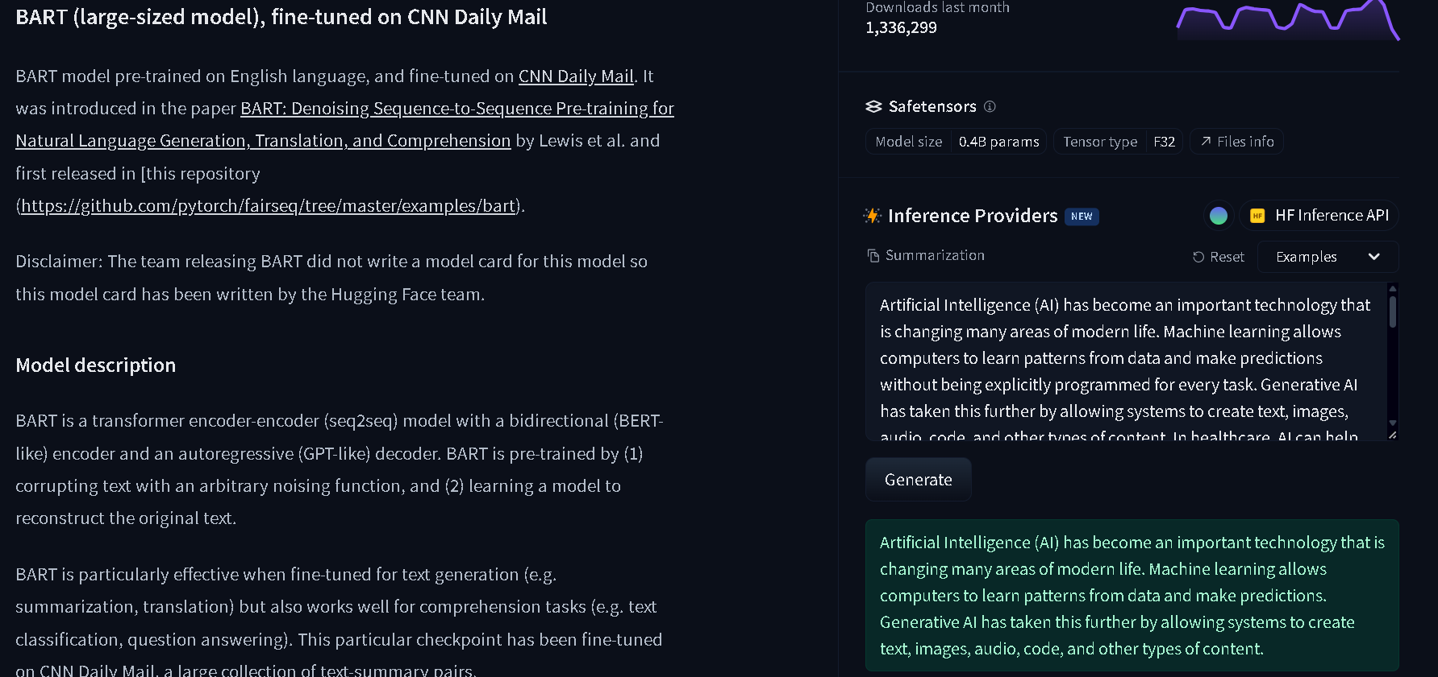
Figure 3: BART Large CNN Summarization test result

7. Comparison of Model Outputs
Model | Task | Input / Test | Observation
GPT-2 | Text Generation | Artificial Intelligence is changing the way… | Generated a natural-language continuation about AI, applications, innovation, and the future.
DistilBERT SST-2 | Sentiment Analysis | I really enjoyed learning about artificial intelligence today. | Predicted POSITIVE with 1.000 displayed score.
BART Large CNN | Summarization | Long paragraph about AI and its applications. | Produced a shorter version focused on the main AI, ML, and Generative AI concepts.

8. Which Model Performed Best?
The three models perform different tasks, so they should not be treated as directly competing models. Each model was evaluated according to its intended purpose:
- GPT-2 was used for generating a continuation of text.
- DistilBERT SST-2 was used for classifying sentiment and clearly identified the provided sentence as positive.
- BART Large CNN was used for summarization and, with the longer input, successfully condensed the main information.
For this exercise, the model that showed the clearest task-specific result was DistilBERT for sentiment classification and BART for the longer summarization example. GPT-2 also successfully demonstrated text generation. Because the tasks are different, there is no single overall winner.

9. Observations
- Different AI models are designed and fine-tuned for different tasks.
- GPT-2 can generate a continuation based on the given text.
- DistilBERT can classify the sentiment of text into positive or negative categories.
- BART can summarize longer text by retaining selected main ideas.
- The quality of a model output depends on the input and the task for which the model was designed.
- Browser-based Hugging Face inference made it possible to test models without resolving local Transformers/PyTorch dependency conflicts.

10. Tools & Technologies Used
- Python / Google Colab (learning and previous NLP workflow)
- Hugging Face Model Hub
- GPT-2
- DistilBERT SST-2
- BART Large CNN
- Natural Language Processing (NLP)
- Generative AI
- GitHub

11. Challenges Faced
- Local Hugging Face Transformers/PyTorch environment produced package and dependency conflicts in Google Colab.
- The first BART test used a short input and did not clearly demonstrate text reduction.
- A longer input was then used to demonstrate summarization more effectively.
- Understanding the difference between a base model and a task-specific fine-tuned model was required for the DistilBERT test.

12. Conclusion
Day 15 introduced the evolution of AI from traditional approaches to Machine Learning, Deep Learning, NLP, Generative AI, and Large Language Models. Hugging Face Model Hub was explored and three models were tested for text generation, sentiment analysis, and summarization. The experiments demonstrated that different models are optimized for different NLP tasks and that model outputs should be evaluated according to the task they are designed to perform.

